# 基于SSM框架的借阅管理系统的设计

学院：信息技术学院

专业：计算机科学与技术

姓名：杨帆

学号：20154071102

黑龙江八一农垦大学

日期：2018年11月15日

## 系统总体设计

### 系统功能简介

借阅管理系统主要由借阅信息的基本情况组成，它的主要功能是完成对上述内容的查询、添加、修改、删除、导入导出等操作；以及对分类的关联查询等操作。

### 数据库及表的设计

1、数据库及表的建立

数据库名：zuopin102

数据库使用Mysql，打开Mysql，新建数据库及表：

create database zuopin102 default character set utf-8;

use zuopin102;

创建如下4个表：

①创建borrow表（借阅信息）

CREATE TABLE `borrow` (

`borrowid` varchar(11) NOT NULL COMMENT '借阅编号',

`userid` varchar(20) DEFAULT NULL COMMENT '用户编号',

`bookid` varchar(20) DEFAULT NULL COMMENT '书籍编号',

`stime` char(10) DEFAULT NULL COMMENT '借阅时间',

`etime` char(10) DEFAULT NULL COMMENT '还书时间',

`borrowremark` varchar(255) DEFAULT NULL COMMENT '书籍状态，1为已还，0为未还',

PRIMARY KEY (`borrowid`)

) ENGINE=InnoDB DEFAULT CHARSET=utf8;

②创建borrowkind表（书籍分类信息）

CREATE TABLE `borrowkind` (

`kind_id` varchar(10) NOT NULL COMMENT '借阅书籍编号',

`kind_name` varchar(255) DEFAULT NULL COMMENT '书籍种类',

`kind_remark` varchar(255) DEFAULT NULL COMMENT '书籍简介',

PRIMARY KEY (`kind_id`)

) ENGINE=InnoDB DEFAULT CHARSET=utf8;

③创建user表（用户表）

CREATE TABLE `user` (

`userId` int(11) NOT NULL AUTO_INCREMENT,

`userName` varchar(50) DEFAULT NULL,

`password` varchar(50) DEFAULT NULL,

`createTime` varchar(50) DEFAULT NULL,

`roleId` int(255) DEFAULT NULL,

`image` varchar(255) DEFAULT NULL,

PRIMARY KEY (`userId`)

) ENGINE=InnoDB AUTO_INCREMENT=22 DEFAULT CHARSET=utf8;

④创建loginfo表（登录信息）

CREATE TABLE `loginfo` (

`logid` int(11) NOT NULL AUTO_INCREMENT,

`userid` varchar(20) DEFAULT NULL,

`logintime` varchar(255) DEFAULT NULL,

PRIMARY KEY (`logid`)

) ENGINE=InnoDB AUTO_INCREMENT=111 DEFAULT CHARSET=utf8;

2、分别向上述对应表中插入数据

①borrow表

INSERT INTO `borrow` VALUES ('1010','1101','1','2018.11.2','2018.11.12','0'),('1011','1102','1','2018.11.2','2018.11.11','1'),('1012','1103','2','2018.11.2','2018.11.11','0'),('1013','1104','1','2018.11.2','2018.11.11','0'),('1014','1105','3','2018.11.1','2018.11.11','0'),('1015','1106','3','2018.11.2','2018.11.12','0'),('1016','1107','2','2018.11.2','2018.11.11','0'),('1017','1108','3','2018.11.2','2018.11.11','0'),('1018','1109','3','2018.11.2','2018.11.11','0'),('1019','1110','3','2018.11.2','2018.11.11','0'),('1029','32165','2','2018.11.2','2018.11.16','1');

②borrowkind表

INSERT INTO `borrowkind` VALUES ('1','玄幻','书籍简介'),('2','爱情','书籍简介'),('3','真理','书籍简介');

③user表

INSERT INTO `user` VALUES (1,'admin','1','2017-5-5 11:48:27',1,'upload/e2f77e06-0342-433f-bff7-ab7b8a10dca1.jpg'),(5,'liulijie','1','2017-5-5 11:48:27',2,NULL),(6,'taijianhua','1','2017-5-5 11:51:31',2,NULL),(8,'20134071101','1','2017-5-5 12:14:02',3,NULL),(9,'20134071102','1','2017-5-5 12:14:39',3,NULL),(10,'20134071103','1','2017-5-5 12:14:54',3,NULL),(11,'20134071104','1','2017-5-5 12:15:12',3,NULL),(12,'20134071105','1','2017-5-5 12:15:31',3,NULL),(13,'20134071106','1','2017-5-5 12:15:46',3,NULL),(14,'20134071107','1','2017-5-5 12:16:38',3,NULL),(15,'20134071108','1','2017-5-5 12:16:57',3,NULL),(16,'20134071113','1','2017-5-5 12:17:39',3,NULL),(17,'20134071115','1','2017-5-5 12:18:14',3,NULL),(18,'20134071116','1','2017-5-5 12:18:41',3,NULL),(19,'20134071117','1','2017-5-5 12:19:21',3,NULL),(20,'20134071118','1','2017-5-5 12:19:36',3,NULL),(21,'zhujingfu','1','2017-5-8 16:51:29',2,NULL);

④loginfo表

INSERT INTO `loginfo` VALUES (1,'1','2015-11-18 18:11:06'),(37,'1','2017-10-14 11:39:27'),(38,'1','2017-10-14 14:30:54'),(39,'1','2017-10-14 15:00:07'),(40,'1','2018-10-27 09:32:58'),(41,'1','2018-10-27 09:59:23'),(42,'1','2018-10-27 10:15:16'),(43,'1','2018-10-27 10:17:27'),(44,'1','2018-10-27 10:21:08'),(45,'1','2018-10-27 10:27:48'),(46,'1','2018-10-27 10:31:05'),(47,'1','2018-10-27 10:40:43'),(48,'1','2018-10-27 11:03:23'),(49,'1','2018-10-27 11:13:17'),(50,'1','2018-10-27 11:33:43'),(51,'1','2018-10-27 11:48:54'),(52,'1','2018-10-27 14:43:03'),(53,'1','2018-10-27 15:03:30'),(54,'1','2018-10-27 15:08:55'),(55,'1','2018-10-27 15:12:31'),(56,'1','2018-10-27 15:21:31'),(57,'1','2018-10-27 15:22:44'),(58,'1','2018-10-27 15:26:06'),(59,'1','2018-10-27 15:32:30'),(60,'1','2018-10-27 15:36:44'),(61,'1','2018-10-27 15:52:02'),(62,'1','2018-10-27 16:06:50'),(63,'1','2018-10-27 16:09:22'),(64,'1','2018-10-27 16:09:31'),(65,'1','2018-10-27 16:12:58'),(66,'1','2018-10-27 16:19:36'),(67,'1','2018-10-27 16:24:19'),(68,'1','2018-10-27 16:30:12'),(69,'1','2018-10-27 16:30:27'),(70,'1','2018-10-27 16:39:00'),(71,'1','2018-10-27 16:39:09'),(72,'1','2018-10-27 16:44:47'),(73,'1','2018-10-27 16:47:34'),(74,'1','2018-10-27 18:53:53'),(75,'1','2018-10-27 18:54:12'),(76,'1','2018-10-27 19:01:15'),(77,'1','2018-10-27 19:05:21'),(78,'1','2018-10-27 19:06:17'),(79,'1','2018-10-27 19:12:36'),(80,'1','2018-10-27 19:19:13'),(81,'1','2018-10-27 19:20:26'),(82,'1','2018-10-27 19:21:49'),(83,'1','2018-10-27 19:25:19'),(84,'1','2018-10-27 19:32:32'),(85,'1','2018-10-27 19:35:12'),(86,'1','2018-10-27 19:42:36'),(87,'1','2018-10-27 19:44:48'),(88,'1','2018-10-27 19:57:46'),(89,'1','2018-10-27 20:33:33'),(90,'1','2018-10-27 20:34:14'),(91,'1','2018-10-27 20:39:23'),(92,'1','2018-10-27 20:40:07'),(93,'1','2018-10-27 20:40:17'),(94,'1','2018-11-03 12:23:22'),(95,'1','2018-11-03 12:29:40'),(96,'1','2018-11-03 14:50:59'),(97,'1','2018-11-03 15:25:36'),(98,'1','2018-11-03 15:28:21'),(99,'1','2018-11-03 15:39:55'),(100,'1','2018-11-03 15:58:09'),(101,'1','2018-11-03 16:38:51'),(102,'1','2018-11-03 16:59:48'),(103,'1','2018-11-03 17:15:57'),(104,'1','2018-11-03 17:18:05'),(105,'1','2018-11-03 19:01:20'),(106,'1','2018-11-06 21:35:19'),(107,'1','2018-11-06 21:53:09'),(108,'1','2018-11-07 08:39:25'),(109,'1','2018-11-07 08:50:32'),(110,'1','2018-11-07 08:54:12');

3、borrow表结构

|  |  |  |  |  |
| --- | --- | --- | --- | --- |
| 字段 | 字段类型 | 是否可为空 | 备注 | 其他 |
| borrowid | int  Not null  primary key | NO | 借阅编号 |  |
| userid | varchar(20)  not null, | NO | 用户编号 |  |
| bookid | varchar(20) | NO | 书籍编号 |  |
| stime | char(10) | YES | 借阅时间 |  |
| etime | char(10) | YES | 还书时间 |  |
| borrowremark | varchar(20) | YES | 书籍状态 |  |

**borrowkind表结构**

|  |  |  |  |  |
| --- | --- | --- | --- | --- |
| 字段 | 字段类型 | 是否可为空 | 备注 | 其他 |
| Kind_id | varchar(10)  Not null  primary key | NO | 借阅书籍编号 |  |
| Kind_name | varchar(20) | YES | 书籍种类 |  |
| Kind_rermark | varchar(20) | YES | 书籍简介 |  |

**loginfo表结构**

|  |  |  |  |  |
| --- | --- | --- | --- | --- |
| 字段 | 字段类型 | 是否可为空 | 备注 | 其他 |
| logid | int(11)  Not null  primary key | NO | 登录编号 | AUTO_INCREMENT |
| userid | varchar(20) | YES | 用户编号 |  |
| logintime | varchar(20) | YES | 登录时间 |  |

user表结构

|  |  |  |  |  |
| --- | --- | --- | --- | --- |
| 字段 | 字段类型 | 是否可为空 | 备注 | 其他 |
| userId | int  Not null  primary key | NO | 用户编号 | AUTO_INCREMENT |
| userName | varchar(50) | YES | 用户名 |  |
| password | varchar(50) | YES | 密码 |  |
| createTime | varchar(50) | YES | 创建时间 |  |
| roleId | int(255) | YES | 用户权限 |  |
| image | varchar(255) | YES | 用户头像 |  |

### 系统功能框图

借阅信息管理系统登录界面

借阅信息管理系统主界面

借阅信息管理

显示全部

借阅信息

借阅的

增删改查

用户管理

修改密码

信息修改

退出登录

查看日志

## 系统功能实现图解

### 系统登录页面

用户名：admin

登录密码：1

注：用户名以及密码已设计好，正确输入验证码后直接点击“登录”按钮即可。

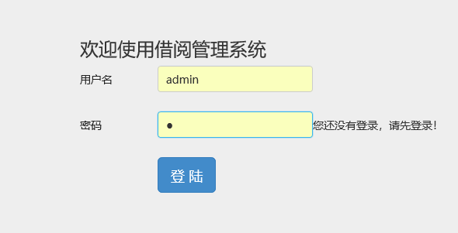

图1

### 系统主界面

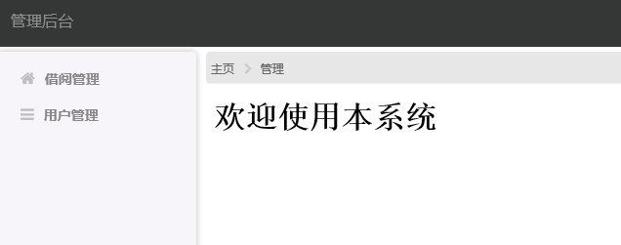

图2

### 借阅表的功能实现

#### 分页显示全部数据

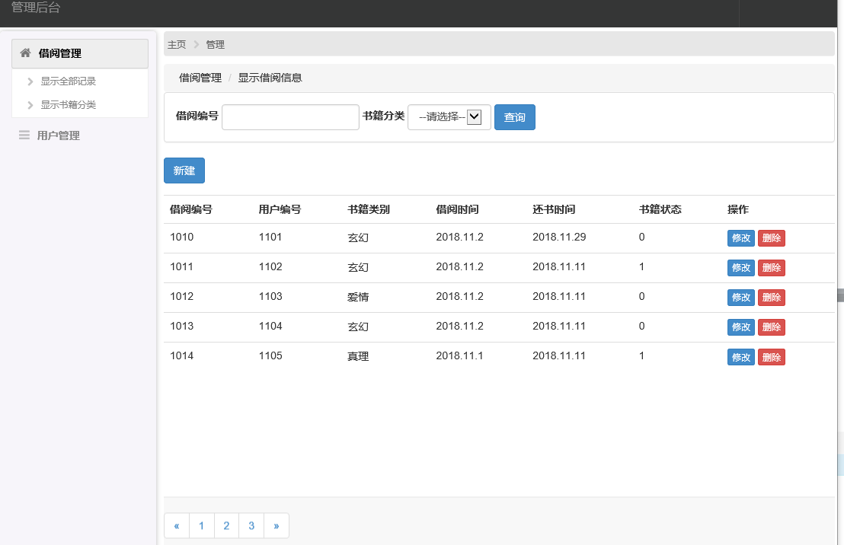

#### 添加数据 ： 添加如下借阅信息

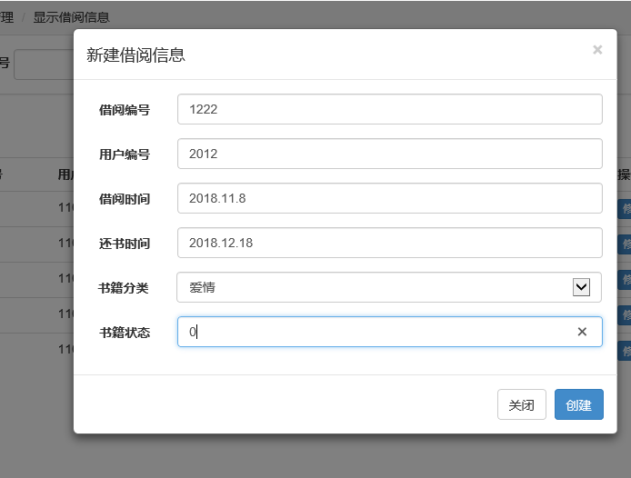

添加成功界面：

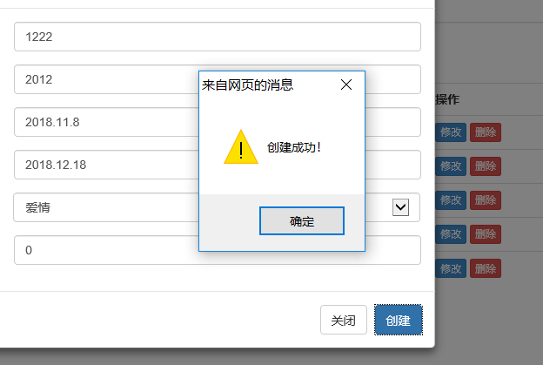

#### 修改数据

修改借阅编号为：1222的借阅信息，把还书时间：2018.12.18修改为：2018.12.16，如下图

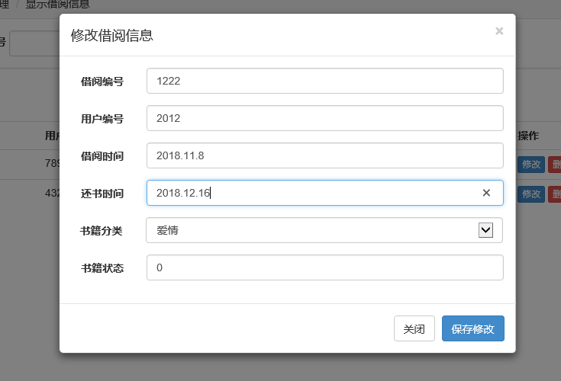

修改成功界面如下：

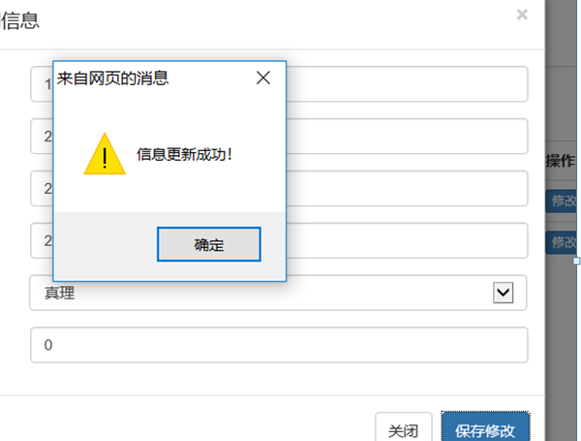

#### 删除数据

删除借阅编号为：1222的借阅信息，删除成功界面如下：

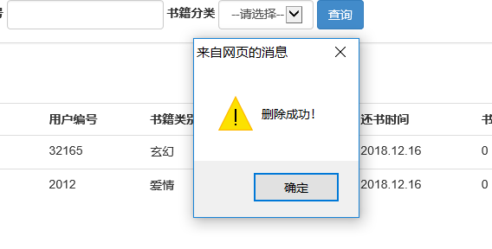

### 书籍分类表的功能实现

#### 显示全部数据

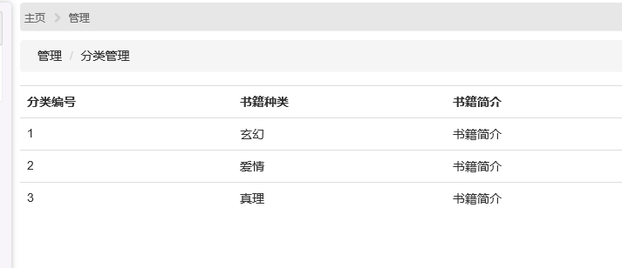

### 修改密码的实现

如下图，把原密码“1”修改为“123”：

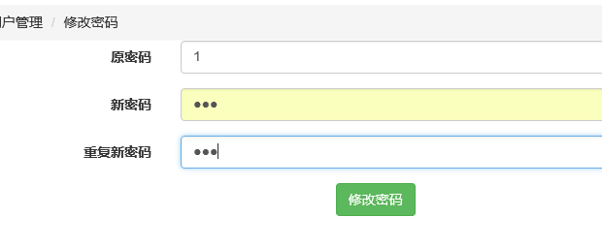

修改成功如下图：

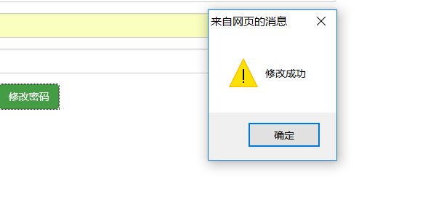

### 登录日志的实现

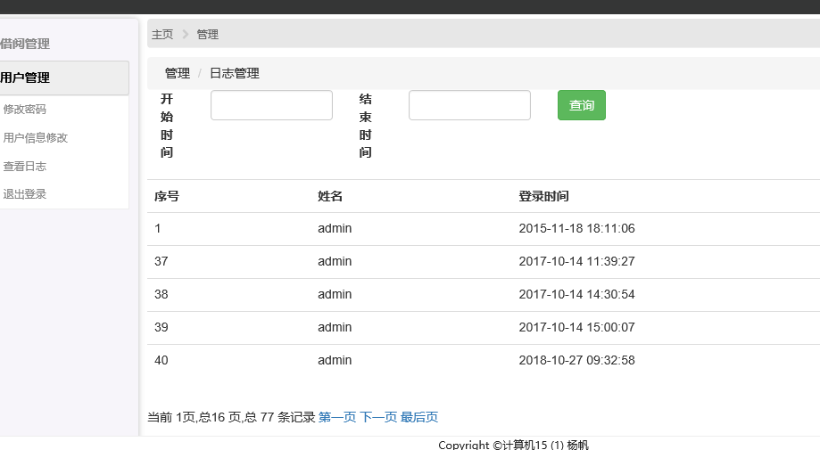

### 退出登录的实现

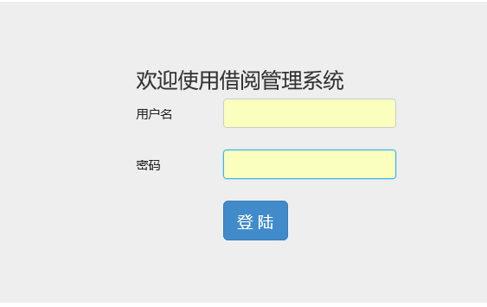

## 系统的具体编码

### 项目文件结构

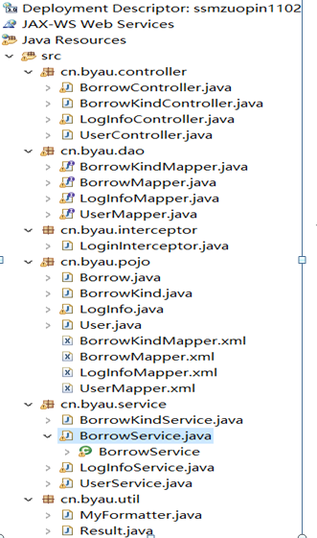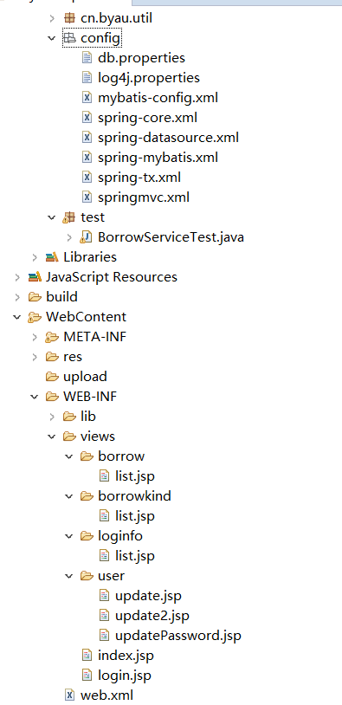

### model 层实体类

#### Borrow.java

package cn.byau.pojo;

public class Borrow {

private String borrowId;

private String userId;

private String bookId;

private String stime;

private String etime;

private String borrowRemark;

private BorrowKind borrowKind;

public Borrow() {

super();

}

public Borrow(String borrowId, String userId, String bookId, String stime, String etime,

String borrowRemark) {

super();

this.borrowId = borrowId;

this.userId = userId;

this.bookId = bookId;

this.stime = stime;

this.etime = etime;

this.borrowRemark = borrowRemark;

}

public String getBorrowId() {

return borrowId;

}

public void setBorrowId(String borrowId) {

this.borrowId = borrowId;

}

public String getUserId() {

return userId;

}

public void setUserId(String userId) {

this.userId = userId;

}

public String getBookId() {

return bookId;

}

public void setBookId(String bookId) {

this.bookId = bookId;

}

public String getStime() {

return stime;

}

public void setStime(String stime) {

this.stime = stime;

}

public String getEtime() {

return etime;

}

public void setEtime(String etime) {

this.etime = etime;

}

public String getBorrowRemark() {

return borrowRemark;

}

public void setBorrowRemark(String borrowRemark) {

this.borrowRemark = borrowRemark;

}

public BorrowKind getBorrowKind() {

return borrowKind;

}

public void setBorrowKind(BorrowKind borrowKind) {

this.borrowKind = borrowKind;

}

@Override

public String toString() {

return "Borrow [borrowId=" + borrowId + ", userId=" + userId + ", bookId=" + bookId

+ ", stime=" + stime + ", etime=" + etime + ", borrowRemark=" + borrowRemark

+ "]";

}

}

### mapper(dao) 层实现

#### BorrowMapper.java

package cn.byau.dao;

import java.util.List;

import java.util.Map;

import cn.byau.pojo.Borrow;

public interface BorrowMapper {

/**

* 根据 courseId 删除一条记录

* @param courseId

* @return 被删除的记录个数

*/

int delete(String courseId);

/**

* 添加一条记录

* @param course

* @return

*/

int save(Borrow borrow);

/**

* 根据courseId查询一条记录

* @param courseId

* @return

*/

Borrow getById(String borrowId);

/**

* 修改一条记录

*

* @param course

* @return

*/

int update(Borrow borrow);

/**

* 根据couresId的值进行模糊查询，得到的记录数

* @param courseId

* @return

*/

int count(String borrowId);

/**

* 根据courseId的值进行模糊查询后分页得到的记录数

* @param map

* @return

*/

List<Borrow> listByPage(Borrow borrow);

List<Borrow> list();

}

#### BorrowMapper.xml

<?xml version=*"1.0"* encoding=*"UTF-8"* ?>

<!DOCTYPE mapper PUBLIC "-//mybatis.org//DTD Mapper 3.0//EN" "http://mybatis.org/dtd/mybatis-3-mapper.dtd" >

<mapper namespace=*"cn.byau.dao.BorrowMapper"*>

<resultMap id=*"BaseResultMap"* type=*"Borrow"*>

<id column=*"borrowid"* property=*"borrowId"* jdbcType=*"VARCHAR"* />

<result column=*"userid"* property=*"userId"* jdbcType=*"VARCHAR"* />

<result column=*"bookid"* property=*"bookId"* jdbcType=*"VARCHAR"* />

<result column=*"stime"* property=*"stime"* jdbcType=*"CHAR"* />

<result column=*"etime"* property=*"etime"* jdbcType=*"CHAR"* />

<result column=*"borrowremark"* property=*"borrowRemark"* jdbcType=*"VARCHAR"* />

</resultMap>

<resultMap id=*"hResultMap"* type=*"Borrow"*>

<id column=*"borrowid"* property=*"borrowId"* jdbcType=*"VARCHAR"* />

<result column=*"userid"* property=*"userId"* jdbcType=*"VARCHAR"* />

<result column=*"bookid"* property=*"bookId"* jdbcType=*"VARCHAR"* />

<result column=*"stime"* property=*"stime"* jdbcType=*"CHAR"* />

<result column=*"etime"* property=*"etime"* jdbcType=*"CHAR"* />

<result column=*"borrowremark"* property=*"borrowRemark"* jdbcType=*"VARCHAR"* />

<association property=*"borrowKind"* javaType=*"BorrowKind"*>

<id column=*"kind_id"* property=*"kindId"* jdbcType=*"VARCHAR"* />

<result column=*"kind_name"* property=*"kindName"* jdbcType=*"VARCHAR"* />

<result column=*"kind_remark"* property=*"kindRemark"* jdbcType=*"VARCHAR"* />

</association>

</resultMap>

<sql id=*"Base_Column_List"*>

borrowid, userid, bookid, stime, etime, borrowremark

</sql>

<select id=*"getById"* resultMap=*"BaseResultMap"*

parameterType=*"java.lang.String"*>

select

<include refid=*"Base_Column_List"* />

from borrow

where borrowid = #{borrowId,jdbcType=VARCHAR}

</select>

<select id=*"list"* resultMap=*"BaseResultMap"*>

select

<include refid=*"Base_Column_List"* />

from borrow

</select>

<select id=*"count"* resultType=*"java.lang.Integer"*

parameterType=*"String"*>

select count(*) from borrow where borrowid like

concat('%',#{borrowId},'%')

</select>

<select id=*"listByPage"* resultMap=*"hResultMap"*>

select b.*,bk.kind_name

from borrowkind bk,borrow b

where bk.kind_id=b.bookid and borrowid like

concat('%',#{borrowId},'%')

<if test=*"bookId != null and bookId != ''"* >

and bookid= #{bookId}

</if>

</select>

<delete id=*"delete"*>

delete from borrow

where borrowid = #{borrowId,jdbcType=VARCHAR}

</delete>

<insert id=*"save"* parameterType=*"Borrow"*>

insert into borrow

<trim prefix=*"("* suffix=*")"* suffixOverrides=*","*>

<if test=*"borrowId != null"*>

borrowid,

</if>

<if test=*"userId != null"*>

userid,

</if>

<if test=*"bookId != null"*>

bookid,

</if>

<if test=*"stime != null"*>

stime,

</if>

<if test=*"etime != null"*>

etime,

</if>

<if test=*"borrowRemark != null"*>

borrowremark,

</if>

</trim>

<trim prefix=*"values ("* suffix=*")"* suffixOverrides=*","*>

<if test=*"borrowId != null"*>

#{borrowId,jdbcType=VARCHAR},

</if>

<if test=*"userId != null"*>

#{userId,jdbcType=VARCHAR},

</if>

<if test=*"bookId != null"*>

#{bookId,jdbcType=VARCHAR},

</if>

<if test=*"stime != null"*>

#{stime,jdbcType=CHAR},

</if>

<if test=*"etime != null"*>

#{etime,jdbcType=CHAR},

</if>

<if test=*"borrowRemark != null"*>

#{borrowRemark,jdbcType=VARCHAR},

</if>

</trim>

</insert>

<update id=*"update"* parameterType=*"Borrow"*>

update borrow

<set>

<if test=*"userId != null"*>

userid = #{userId,jdbcType=VARCHAR},

</if>

<if test=*"bookId != null"*>

bookid = #{bookId,jdbcType=VARCHAR},

</if>

<if test=*"stime != null"*>

stime = #{stime,jdbcType=CHAR},

</if>

<if test=*"etime != null"*>

etime = #{etime,jdbcType=CHAR},

</if>

<if test=*"borrowRemark != null"*>

borrowremark = #{borrowRemark,jdbcType=VARCHAR},

</if>

</set>

where borrowid =#{borrowId,jdbcType=VARCHAR}

</update>

<insert id=*"insertBatch"* parameterType=*"java.util.List"*>

insert into borrow (borrowid, userid,

bookid, stime, etime,

borrowremark) values

<foreach collection=*"list"* item=*"borrow"*

separator=*","*>

(#{borrow.borrowId,jdbcType=VARCHAR}, #{borrow.userId,jdbcType=VARCHAR},

#{borrow.bookId,jdbcType=VARCHAR},

#{borrow.stime,jdbcType=CHAR},

#{borrow.etime,jdbcType=CHAR},

#{borrow.borrowRemark,jdbcType=VARCHAR})

</foreach>

</insert>

<delete id=*"deleteBatch"* parameterType=*"String"*>

delete from borrow where borrowid in

<foreach item=*"borrowId"* collection=*"array"* open=*"("* separator=*","* close=*")"*>

#{borrowId}

</foreach>

</delete>

</mapper>

### service 层实现

#### BorrowService.java

package cn.byau.service;

import cn.byau.dao.BorrowMapper;

import cn.byau.pojo.Borrow;

import java.io.File;

import java.io.FileInputStream;

import java.io.InputStream;

import java.io.OutputStream;

import java.net.URLEncoder;

import java.text.SimpleDateFormat;

import java.util.ArrayList;

import java.util.Date;

import org.springframework.stereotype.Service;

import java.util.List;

import java.util.Map;

import javax.servlet.http.HttpServletResponse;

import org.apache.poi.hssf.usermodel.HSSFRow;

import org.apache.poi.hssf.usermodel.HSSFSheet;

import org.apache.poi.hssf.usermodel.HSSFWorkbook;

import org.apache.poi.ss.usermodel.CellStyle;

import org.apache.poi.ss.usermodel.Font;

import org.apache.poi.xssf.usermodel.XSSFCell;

import org.apache.poi.xssf.usermodel.XSSFFont;

import org.apache.poi.xssf.usermodel.XSSFRow;

import org.apache.poi.xssf.usermodel.XSSFSheet;

import org.apache.poi.xssf.usermodel.XSSFWorkbook;

import org.springframework.beans.factory.annotation.Autowired;

import org.springframework.web.multipart.MultipartFile;

/**

* Created by tjh on 2017/5/13.

*/

@Service("BorrowService")

public class BorrowService {

@Autowired

private BorrowMapper borrowDao;

public List<Borrow> listByPage(Borrow borrow) {

return borrowDao.listByPage(borrow);

}

public void save(Borrow borrow) {

borrowDao.save(borrow);

}

public Borrow getById(String borrowId) {

return borrowDao.getById(borrowId);

}

public void update(Borrow borrow) {

borrowDao.update(borrow);

}

public void delete(String borrowId) {

borrowDao.delete(borrowId);

}

public void deleteBatch(String ids[]) {

borrowDao.deleteBatch(ids);

}

}

### Controller 层实现

#### BorrowController.java

package cn.byau.controller;

import java.util.HashMap;

import java.util.List;

import java.util.Map;

import javax.annotation.Resource;

import javax.servlet.http.HttpServletRequest;

import javax.servlet.http.HttpServletResponse;

import org.springframework.stereotype.Controller;

import org.springframework.web.bind.annotation.RequestMapping;

import org.springframework.web.bind.annotation.RequestParam;

import org.springframework.web.bind.annotation.ResponseBody;

import org.springframework.web.multipart.MultipartFile;

import org.springframework.web.servlet.ModelAndView;

import com.github.pagehelper.PageHelper;

import com.github.pagehelper.PageInfo;

import cn.byau.pojo.Borrow;

import cn.byau.pojo.BorrowKind;

import cn.byau.pojo.LogInfo;

import cn.byau.service.BorrowKindService;

import cn.byau.service.BorrowService;

import cn.byau.util.Result;

/**

* Created by tjh on 2017/5/13.

*/

@Controller

@RequestMapping("/borrow")

public class BorrowController {

@Resource(name = "BorrowService")

private BorrowService borrowService;

@Resource(name = "borrowKindService")

private BorrowKindService borrowKindService;

/**

* 跳转到分页显示页面

*

* @param pageNum

* 为当前页号

* @param courseId

* 为查询的课程编号

* @param request

* @param response

* @return

*/

@RequestMapping("/listByPage")

public ModelAndView listByPage(@RequestParam(defaultValue = "1", required = false) Integer pageNo,

@RequestParam(defaultValue = "5", required = false) Integer pageSize,

@RequestParam(defaultValue = "", required = false) String borrowId,

String bookId,

HttpServletRequest request,

HttpServletResponse response) {

ModelAndView mv = new ModelAndView();

Borrow borrow=new Borrow();

borrow.setBorrowId(borrowId);

borrow.setBookId(bookId);

mv.setViewName("/WEB-INF/views/borrow/list.jsp");

PageHelper.startPage(pageNo, pageSize);

List<Borrow> borrowList = borrowService.listByPage(borrow);

PageInfo<Borrow> pageInfo = new PageInfo<Borrow>(borrowList);

request.setAttribute("pageInfo", pageInfo);

request.setAttribute("borrowId", borrowId);

request.setAttribute("bookId", bookId);

List<BorrowKind> borrowKindList = borrowKindService.list();

request.setAttribute("borrowKindlist", borrowKindList);

return mv;

}

/**

* 跳转到添加页面

*

* @param request

* @return

*/

@RequestMapping("/save")

@ResponseBody

public Result save(Borrow borrow) {

Result result = new Result();

try{

borrowService.save(borrow);

result.setMsg("OK");

}catch(Exception e){

result.setMsg("FAIL");

}

return result;

}

/**

* 跳转到更新页面

*

* @param request

* @return

*/

@RequestMapping("/getById")

@ResponseBody

public Borrow updatePage(HttpServletRequest request) {

String borrowId = request.getParameter("borrowId");

Borrow borrow = borrowService.getById(borrowId);

return borrow;

}

@RequestMapping("/update")

@ResponseBody

public Result update(Borrow borrow) {

Result result = new Result();

try {

borrowService.update(borrow);

result.setMsg("OK");

} catch (Exception e) {

result.setMsg("FAIL");

}

return result;

}

@RequestMapping("/delete")

@ResponseBody

public Result delete(String borrowId) {

Result result = new Result();

try {

borrowService.delete(borrowId);

result.setMsg("OK");

} catch (Exception e) {

result.setMsg("FAIL");

}

return result;

}

}

### JSP 页面

#### list.jsp

<%@ page language=*"java"* import=*"java.util.*"* pageEncoding=*"utf-8"*%>

<%@ page import=*"java.net.URLEncoder"*%>

<%@ taglib prefix=*"c"* uri=*"http://java.sun.com/jsp/jstl/core"*%>

<%

String path = request.getContextPath();

String basePath = request.getScheme() + "://" + request.getServerName() + ":" + request.getServerPort()

+ path + "/";

%>

<!DOCTYPE html>

<html>

<head>

<title>借阅信息列表</title>

<meta http-equiv=*"keywords"* content=*"keyword1,keyword2,keyword3"*>

<meta http-equiv=*"description"* content=*"this is my page"*>

<meta http-equiv=*"content-type"* content=*"text/html; charset=UTF-8"*>

<link rel=*"stylesheet"*

href=*"*${pageContext.request.contextPath}*/res/css/bootstrap.min.css"*>

<script type=*"text/javascript"*

src=*"*${pageContext.request.contextPath}*/res/js/jquery.min.js"*></script>

<script type=*"text/javascript"*

src=*"*${pageContext.request.contextPath}*/res/js/bootstrap.min.js"*></script>

</head>

<body>

<div style="padding: *0px*; margin: *0px*;">

<ul class=*"breadcrumb"* style="margin: *0px*; padding-left: *20px*;">

<li>借阅管理</li>

<li>显示借阅信息</li>

</ul>

</div>

<div class=*"panel panel-default"*>

<div class=*"panel-body"*>

<form class=*"form-inline"* method=*"get"*

action=*"*${pageContext.request.contextPath }*/borrow/listByPage.action"*>

<div class=*"form-group"*>

<label for=*"borrowId"*>借阅编号</label> <input type=*"text"*

class=*"form-control"* id=*"courseId"* value=*"*${borrowId}*"*

name=*"borrowId"* />

</div>

<div class=*"form-group"*>

<label for=*"bookId"*>书籍分类</label> <select class=*"form-control"*

id=*"bookId"* name=*"bookId"*>

<option value=*""*>--请选择--</option>

<c:forEach items=*"*${borrowKindlist}*"* var=*"item"*>

<option value=*"*${item.kindId}*"*

<c:if test="${item.kindId == bookId}">selected</c:if>>

${item.kindName }</option>

</c:forEach>

</select>

</div>

<button type=*"submit"* class=*"btn btn-primary"*>查询</button>

</form>

</div>

</div>

<a href=*"#"* class=*"btn btn-primary"* data-toggle=*"modal"*

data-target=*"#newBorrowDialog"* onclick="clearBorrow()">新建</a>

<div class=*"row"* style="padding: *15px*;">

<table class=*"table "*>

<tr>

<th>借阅编号</th>

<th>用户编号</th>

<th>书籍类别</th>

<th>借阅时间</th>

<th>还书时间</th>

<th>书籍状态</th>

<th>操作</th>

</tr>

<c:forEach items=*"*${pageInfo.list}*"* var=*"borrow"* varStatus=*"v"*>

<tr>

<td>${borrow.borrowId }</td>

<td>${borrow.userId}</td>

<td>${borrow.borrowKind.kindName}</td>

<td>${borrow.stime}</td>

<td>${borrow.etime}</td>

<td>${borrow.borrowRemark}</td>

<td><a href=*"#"* class=*"btn btn-primary btn-xs"*

data-toggle=*"modal"* data-target=*"#borrowEditDialog"*

onclick=*"editBorrow(*${borrow.borrowId }*)"*>修改</a> <a href=*"#"*

class=*"btn btn-danger btn-xs"*

onclick=*"deleteBorrow(*${borrow.borrowId }*)"*>删除</a></td>

</tr>

</c:forEach>

</table>

<nav class=*"navbar navbar-default navbar-fixed-bottom"*>

<ul class=*"pagination"*>

<li><a

href=*"?borrowId=*<c:out value="${borrowId}"/>*&pageNo=*<c:out value="${pageNo-1 }"/>*"*

aria-label=*"Previous"*> <span aria-hidden=*"true"*>&laquo;</span>

</a></li>

<c:forEach var=*"i"* begin=*"1"* end=*"*${pageInfo.pages}*"* step=*"1"*>

<li><a

href=*"?borrowId=*<c:out value="${borrowId}"/>*&pageNo=*<c:out value="${i}"/>*"*><c:out

value=*"*${i}*"* /></a></li>

</c:forEach>

<li><a

href=*"?borrowId=*<c:out value="${borrowId}"/>*&pageNo=*<c:out value="${pageNo+1 }"/>*"*

aria-label=*"Next"*> <span aria-hidden=*"true"*>&raquo;</span>

</a></li>

</ul>

</nav>

</div>

<!-- 创建模态框 -->

<div class=*"modal fade"* id=*"newBorrowDialog"* tabindex=*"-1"*

role=*"dialog"* aria-labelledby=*"myModalLabel"*>

<div class=*"modal-dialog"* role=*"document"*>

<div class=*"modal-content"*>

<div class=*"modal-header"*>

<button type=*"button"* class=*"close"* data-dismiss=*"modal"*

aria-label=*"Close"*>

<span aria-hidden=*"true"*>&times;</span>

</button>

<h4 class=*"modal-title"* id=*"myModalLabel"*>新建借阅信息</h4>

</div>

<div class=*"modal-body"*>

<form class=*"form-horizontal"* id=*"new_borrow_form"*>

<div class=*"form-group"*>

<label for=*"new_borrowId"* class=*"col-sm-2 control-label"*>

借阅编号 </label>

<div class=*"col-sm-10"*>

<input type=*"text"* class=*"form-control"* id=*"new_borrowId"*

placeholder=*"借阅编号"* name=*"borrowId"* />

</div>

</div>

<div class=*"form-group"*>

<label for=*"new_userId"* class=*"col-sm-2 control-label"*>用户编号</label>

<div class=*"col-sm-10"*>

<input type=*"text"* class=*"form-control"* id=*"new_userId"*

placeholder=*"用户编号"* name=*"userId"* />

</div>

</div>

<div class=*"form-group"*>

<label for=*"new_stime"* class=*"col-sm-2 control-label"*>借阅时间</label>

<div class=*"col-sm-10"*>

<input type=*"text"* class=*"form-control"* id=*"new_stime"*

placeholder=*"借阅时间"* name=*"stime"* />

</div>

</div>

<div class=*"form-group"*>

<label for=*"new_etime"* class=*"col-sm-2 control-label"*>还书时间</label>

<div class=*"col-sm-10"*>

<input type=*"text"* class=*"form-control"* id=*"new_etime"*

placeholder=*"还书时间"* name=*"etime"* />

</div>

</div>

<div class=*"form-group"*>

<label for=*"new_bookId"*

style="float: *left*; padding: *7px 15px 0 27px*;">书籍分类</label>

<div class=*"col-sm-10"*>

<select class=*"form-control"* id=*"new_bookId"*

name=*"bookId"*>

<option value=*""*>--请选择--</option>

<c:forEach items=*"*${borrowKindlist}*"* var=*"item"*>

<option value=*"*${item.kindId}*"*>

${item.kindName }</option>

</c:forEach>

</select>

</div>

</div>

<div class=*"form-group"*>

<label for=*"new_borrowRemark"* class=*"col-sm-2 control-label"*>书籍状态</label>

<div class=*"col-sm-10"*>

<input type=*"text"* class=*"form-control"* id=*"new_borrowRemark"*

placeholder=*"书籍状态"* name=*"borrowRemark"* />

</div>

</div>

</form>

</div>

<div class=*"modal-footer"*>

<button type=*"button"* class=*"btn btn-default"* data-dismiss=*"modal"*>关闭</button>

<button type=*"button"* class=*"btn btn-primary"*

onclick="createBorrow()">创建</button>

</div>

</div>

</div>

</div>

<!-- 修改模态框 -->

<div class=*"modal fade"* id=*"borrowEditDialog"* tabindex=*"-1"*

role=*"dialog"* aria-labelledby=*"myModalLabel"*>

<div class=*"modal-dialog"* role=*"document"*>

<div class=*"modal-content"*>

<div class=*"modal-header"*>

<button type=*"button"* class=*"close"* data-dismiss=*"modal"*

aria-label=*"Close"*>

<span aria-hidden=*"true"*>&times;</span>

</button>

<h4 class=*"modal-title"* id=*"myModalLabel"*>修改借阅信息</h4>

</div>

<div class=*"modal-body"*>

<form class=*"form-horizontal"* id=*"edit_borrow_form"*>

<div class=*"form-group"*>

<label for=*"edit_borrowId"* class=*"col-sm-2 control-label"*>

借阅编号 </label>

<div class=*"col-sm-10"*>

<input type=*"text"* class=*"form-control"* id=*"edit_borrowId"*

placeholder=*"借阅编号"* name=*"borrowId"* />

</div>

</div>

<div class=*"form-group"*>

<label for=*"edit_userId"* class=*"col-sm-2 control-label"*>课程名称</label>

<div class=*"col-sm-10"*>

<input type=*"text"* class=*"form-control"* id=*"edit_userId"*

placeholder=*"用户编号"* name=*"userId"* />

</div>

</div>

<div class=*"form-group"*>

<label for=*"edit_stime"* class=*"col-sm-2 control-label"*>借阅时间</label>

<div class=*"col-sm-10"*>

<input type=*"text"* class=*"form-control"* id=*"edit_stime"*

placeholder=*"借阅时间"* name=*"stime"* />

</div>

</div>

<div class=*"form-group"*>

<label for=*"edit_etime"* class=*"col-sm-2 control-label"*>还书时间</label>

<div class=*"col-sm-10"*>

<input type=*"text"* class=*"form-control"* id=*"edit_etime"*

placeholder=*"还书时间"* name=*"etime"* />

</div>

</div>

<div class=*"form-group"*>

<label for=*"edit_bookId"*

style="float: *left*; padding: *7px 15px 0 27px*;">书籍分类</label>

<div class=*"col-sm-10"*>

<select class=*"form-control"* id=*"edit_bookId"*

name=*"bookId"*>

<option value=*""*>--请选择--</option>

<c:forEach items=*"*${borrowKindlist}*"* var=*"item"*>

<option value=*"*${item.kindId}*"*>

${item.kindName }</option>

</c:forEach>

</select>

</div>

</div>

<div class=*"form-group"*>

<label for=*"edit_borrowRemark"* class=*"col-sm-2 control-label"*>书籍状态</label>

<div class=*"col-sm-10"*>

<input type=*"text"* class=*"form-control"* id=*"edit_borrowRemark"*

placeholder=*"书籍状态"* name=*"borrowRemark"* />

</div>

</div>

</form>

</div>

<div class=*"modal-footer"*>

<button type=*"button"* class=*"btn btn-default"* data-dismiss=*"modal"*>关闭</button>

<button type=*"button"* class=*"btn btn-primary"*

onclick="updateBorrow()">保存修改</button>

</div>

</div>

</div>

</div>

<!-- 编写js代码 -->

<script type=*"text/javascript"*>

//清空新建窗口中的数据

**function** clearBorrow() {

$("#new_borrowId").val("");

$("#new_userId").val("");

$("#new_stime").val("");

$("#new_etime").val("");

$("#new_bookId").val("");

$("#new_borrowRemark").val("");

}

// 创建

**function** createBorrow() {

$.post("${pageContext.request.contextPath}/borrow/save.action",

$("#new_borrow_form").serialize(),**function**(data){

**if**(data.msg =="OK"){

alert("创建成功！");

window.location.reload();

}**else**{

alert("创建失败！");

window.location.reload();

}

});

}

// 通过id获取修改的信息

**function** editBorrow(borrowId) {

$.ajax({

type:"get",

url:"${pageContext.request.contextPath}/borrow/getById.action",

data:{"borrowId":borrowId},

success:**function**(data) {

$("#edit_borrowId").val(data.borrowId);

$("#edit_userId").val(data.userId);

$("#edit_stime").val(data.stime);

$("#edit_etime").val(data.etime);

$("#edit_bookId").val(data.bookId);

$("#edit_borrowRemark").val(data.borrowRemark);

}

});

}

// 执行修改操作

**function** updateBorrow() {

$.post("${pageContext.request.contextPath}/borrow/update.action",$("#edit_borrow_form").serialize(),**function**(data){

**if**(data.msg =="OK"){

alert("信息更新成功！");

window.location.reload();

}**else**{

alert("信息更新失败！");

window.location.reload();

}

});

}

// 删除课程

**function** deleteBorrow(borrowId) {

**if**(confirm('确实要删除吗?')) {

$.post("${pageContext.request.contextPath}/borrow/delete.action",{"borrowId":borrowId},

**function**(data){

**if**(data.msg =="OK"){

alert("删除成功！");

window.location.reload();

}**else**{

alert("删除失败！");

window.location.reload();

}

});

}

}

</script>

</body>

</html>

### 配置文件

#### springmvc.xml

<?xml version=*"1.0"* encoding=*"UTF-8"*?>

<beans xmlns=*"http://www.springframework.org/schema/beans"*

xmlns:xsi=*"http://www.w3.org/2001/XMLSchema-instance"*

xmlns:aop=*"http://www.springframework.org/schema/aop"*

xmlns:tx=*"http://www.springframework.org/schema/tx"*

xmlns:context=*"http://www.springframework.org/schema/context"*

xmlns:mvc=*"http://www.springframework.org/schema/mvc"*

xsi:schemaLocation=*"*

*http://www.springframework.org/schema/beans*

*http://www.springframework.org/schema/beans/spring-beans-4.2.xsd*

*http://www.springframework.org/schema/context*

*http://www.springframework.org/schema/context/spring-context-4.2.xsd*

*http://www.springframework.org/schema/aop*

*http://www.springframework.org/schema/aop/spring-aop-4.2.xsd*

*http://www.springframework.org/schema/tx*

*http://www.springframework.org/schema/tx/spring-tx-4.2.xsd*

*http://www.springframework.org/schema/mvc*

*http://www.springframework.org/schema/mvc/spring-mvc-4.2.xsd"*>

<!-- 开启包扫描扫描控制器， -->

<context:component-scan base-package=*"cn.byau.controller"*/>

<!-- 开启注解支持MVC @RequestBody和@ResponseBody 使用mvc:annotation-driven -->

<bean id=*"conversionService"* class=*"org.springframework.format.support.FormattingConversionServiceFactoryBean"*>

<property name=*"formatters"*>

<set>

<bean class=*"cn.byau.util.MyFormatter"*/>

</set>

</property>

</bean>

<mvc:annotation-driven conversion-service=*"conversionService"*/>

<!-- 视图解析器 -->

<!-- <bean class="org.springframework.web.servlet.view.InternalResourceViewResolver">

<property name="viewClass" value="org.springframework.web.servlet.view.JstlView"/>

<property name="contentType" value="text/html"/>

<property name="prefix" value="/WEB-INF/views/"/>

<property name="suffix" value=".jsp"/>

</bean> -->

<bean id=*"multipartResolver"* class=*"org.springframework.web.multipart.commons.CommonsMultipartResolver"*>

<property name=*"defaultEncoding"* value=*"utf-8"*></property>

</bean>

<!-- 配置拦截器 -->

<mvc:interceptors>

<mvc:interceptor>

<mvc:mapping path=*"/**"* />

<bean class=*"cn.byau.interceptor.LoginInterceptor"* />

</mvc:interceptor>

</mvc:interceptors>

</beans>

#### spring-tx.xml

<?xml version=*"1.0"* encoding=*"UTF-8"*?>

<beans xmlns=*"http://www.springframework.org/schema/beans"*

xmlns:xsi=*"http://www.w3.org/2001/XMLSchema-instance"*

xmlns:aop=*"http://www.springframework.org/schema/aop"*

xmlns:tx=*"http://www.springframework.org/schema/tx"*

xmlns:context=*"http://www.springframework.org/schema/context"*

xmlns:mvc=*"http://www.springframework.org/schema/mvc"*

xsi:schemaLocation=*"*

*http://www.springframework.org/schema/beans*

*http://www.springframework.org/schema/beans/spring-beans-4.2.xsd*

*http://www.springframework.org/schema/context*

*http://www.springframework.org/schema/context/spring-context-4.2.xsd*

*http://www.springframework.org/schema/aop*

*http://www.springframework.org/schema/aop/spring-aop-4.2.xsd*

*http://www.springframework.org/schema/tx*

*http://www.springframework.org/schema/tx/spring-tx-4.2.xsd*

*http://www.springframework.org/schema/mvc*

*http://www.springframework.org/schema/mvc/spring-mvc-4.2.xsd"*>

<bean id=*"transactionManager"* class=*"org.springframework.jdbc.datasource.DataSourceTransactionManager"*>

<property name=*"dataSource"* ref=*"dataSource"*></property>

</bean>

<!-- 注解式事务 -->

<tx:annotation-driven transaction-manager=*"transactionManager"*/>

</beans>

#### Spring-mybatis.xml

<?xml version=*"1.0"* encoding=*"UTF-8"*?>

<beans xmlns=*"http://www.springframework.org/schema/beans"*

xmlns:xsi=*"http://www.w3.org/2001/XMLSchema-instance"*

xmlns:aop=*"http://www.springframework.org/schema/aop"*

xmlns:tx=*"http://www.springframework.org/schema/tx"*

xmlns:context=*"http://www.springframework.org/schema/context"*

xmlns:mvc=*"http://www.springframework.org/schema/mvc"*

xsi:schemaLocation=*"*

*http://www.springframework.org/schema/beans*

*http://www.springframework.org/schema/beans/spring-beans-4.2.xsd*

*http://www.springframework.org/schema/context*

*http://www.springframework.org/schema/context/spring-context-4.2.xsd*

*http://www.springframework.org/schema/aop*

*http://www.springframework.org/schema/aop/spring-aop-4.2.xsd*

*http://www.springframework.org/schema/tx*

*http://www.springframework.org/schema/tx/spring-tx-4.2.xsd*

*http://www.springframework.org/schema/mvc*

*http://www.springframework.org/schema/mvc/spring-mvc-4.2.xsd"*>

<!-- mybatis SqlSessionFactory配置 -->

<bean id=*"sqlSessionFactory"* class=*"org.mybatis.spring.SqlSessionFactoryBean"*>

<!-- 指定数据源 -->

<property name=*"dataSource"* ref=*"dataSource"*></property>

<!-- 指定映射文件的位置, -->

<property name=*"mapperLocations"* value=*"classpath:**/cn/byau/pojo/*Mapper.xml"*></property>

<!-- 给包中的类注册别名，可以直接使用类名 -->

<property name=*"typeAliasesPackage"* value=*"cn.byau.pojo"*></property>

<property name=*"configLocation"* value=*"classpath:config/mybatis-config.xml"*/>

</bean>

<!-- 扫包 dao生成dao的实现类-->

<bean class=*"org.mybatis.spring.mapper.MapperScannerConfigurer"*>

<property name=*"basePackage"* value=*"cn.byau.dao"* />

</bean>

</beans>

#### Spring-datasource.xml

<?xml version=*"1.0"* encoding=*"UTF-8"*?>

<beans xmlns=*"http://www.springframework.org/schema/beans"*

xmlns:xsi=*"http://www.w3.org/2001/XMLSchema-instance"*

xmlns:aop=*"http://www.springframework.org/schema/aop"*

xmlns:tx=*"http://www.springframework.org/schema/tx"*

xmlns:context=*"http://www.springframework.org/schema/context"*

xmlns:mvc=*"http://www.springframework.org/schema/mvc"*

xsi:schemaLocation=*"*

*http://www.springframework.org/schema/beans*

*http://www.springframework.org/schema/beans/spring-beans-4.2.xsd*

*http://www.springframework.org/schema/context*

*http://www.springframework.org/schema/context/spring-context-4.2.xsd*

*http://www.springframework.org/schema/aop*

*http://www.springframework.org/schema/aop/spring-aop-4.2.xsd*

*http://www.springframework.org/schema/tx*

*http://www.springframework.org/schema/tx/spring-tx-4.2.xsd*

*http://www.springframework.org/schema/mvc*

*http://www.springframework.org/schema/mvc/spring-mvc-4.2.xsd"*>

<context:property-placeholder location=*"classpath:config/db.properties"* />

<!-- c3p0连接池 -->

<!-- 配置数据源 -->

<bean id=*"dataSource"* class=*"com.alibaba.druid.pool.DruidDataSource"*

destroy-method=*"close"*>

<property name=*"driverClassName"* value=*"${jdbc.driver}"* />

<property name=*"url"* value=*"${jdbc.url}"* />

<property name=*"username"* value=*"${jdbc.username}"* />

<property name=*"password"* value=*"${jdbc.password}"* />

<!-- 配置初始化大小、最小、最大 -->

<property name=*"initialSize"* value=*"${druid.initialSize}"* />

<property name=*"minIdle"* value=*"${druid.minIdle}"* />

<property name=*"maxActive"* value=*"${druid.maxActive}"* />

<!-- 配置获取连接等待超时的时间 -->

<property name=*"maxWait"* value=*"${druid.maxWait}"* />

<!-- 配置间隔多久才进行一次检测，检测需要关闭的空闲连接，单位是毫秒 -->

<property name=*"timeBetweenEvictionRunsMillis"* value=*"${druid.timeBetweenEvictionRunsMillis}"* />

<!-- 配置一个连接在池中最小生存的时间，单位是毫秒 -->

<property name=*"minEvictableIdleTimeMillis"* value=*"${druid.minEvictableIdleTimeMillis}"* />

<property name=*"validationQuery"* value=*"${druid.validationQuery}"* />

<property name=*"testWhileIdle"* value=*"${druid.testWhileIdle}"* />

<property name=*"testOnBorrow"* value=*"${druid.testOnBorrow}"* />

<property name=*"testOnReturn"* value=*"${druid.testOnReturn}"* />

<!-- 打开PSCache，并且指定每个连接上PSCache的大小 如果用Oracle，则把poolPreparedStatements配置为true，mysql可以配置为false。 -->

<property name=*"poolPreparedStatements"* value=*"${druid.poolPreparedStatements}"* />

<property name=*"maxPoolPreparedStatementPerConnectionSize"*

value=*"${druid.maxPoolPreparedStatementPerConnectionSize}"* />

<!-- 配置监控统计拦截的filters -->

<property name=*"filters"* value=*"${druid.filters}"* />

</bean>

</beans>

#### spring-core.xml

<?xml version=*"1.0"* encoding=*"UTF-8"*?>

<beans xmlns=*"http://www.springframework.org/schema/beans"*

xmlns:xsi=*"http://www.w3.org/2001/XMLSchema-instance"*

xmlns:aop=*"http://www.springframework.org/schema/aop"*

xmlns:tx=*"http://www.springframework.org/schema/tx"*

xmlns:context=*"http://www.springframework.org/schema/context"*

xmlns:mvc=*"http://www.springframework.org/schema/mvc"*

xsi:schemaLocation=*"*

*http://www.springframework.org/schema/beans*

*http://www.springframework.org/schema/beans/spring-beans-4.2.xsd*

*http://www.springframework.org/schema/context*

*http://www.springframework.org/schema/context/spring-context-4.2.xsd*

*http://www.springframework.org/schema/aop*

*http://www.springframework.org/schema/aop/spring-aop-4.2.xsd*

*http://www.springframework.org/schema/tx*

*http://www.springframework.org/schema/tx/spring-tx-4.2.xsd*

*http://www.springframework.org/schema/mvc*

*http://www.springframework.org/schema/mvc/spring-mvc-4.2.xsd"*>

<import resource=*"spring-datasource.xml"*/>

<import resource=*"spring-mybatis.xml"*/>

<import resource=*"spring-tx.xml"*/>

<!-- 包扫描 -->

<context:component-scan base-package=*"cn.byau.service"*/>

</beans>

#### mybatis-config.xml

<?xml version=*"1.0"* encoding=*"UTF-8"* ?>

<!DOCTYPE configuration PUBLIC "-//mybatis.org//DTD Config 3.0//EN"

"http://mybatis.org/dtd/mybatis-3-config.dtd">

<configuration>

<!-- 引入 pageHelper插件 -->

<plugins>

<plugin interceptor=*"com.github.pagehelper.PageInterceptor"*>

<!--reasonable：分页合理化参数，默认值为false。

当该参数设置为 true 时，pageNum<=0 时会查询第一页，

pageNum>pages（超过总数时），会查询最后一页。

默认false 时，直接根据参数进行查询。-->

<property name=*"reasonable"* value=*"true"*/>

</plugin>

</plugins>

</configuration>

#### db.properties

jdbc.driver=com.mysql.jdbc.Driver

jdbc.url=jdbc:mysql://localhost:3306/zuopin102?characterEncoding=utf-8

jdbc.username=root

jdbc.password=root

druid.initialSize=10

druid.minIdle=10

druid.maxActive=50

druid.maxWait=60000

druid.timeBetweenEvictionRunsMillis=60000

druid.minEvictableIdleTimeMillis=300000

druid.validationQuery=SELECT 'x'

druid.testWhileIdle=true

druid.testOnBorrow=false

druid.testOnReturn=false

druid.poolPreparedStatements=true

druid.maxPoolPreparedStatementPerConnectionSize=20

druid.filters=stat

#### log4j. properties

# Global logging configuration

log4j.rootLogger=debug, stdout

# Console output...

log4j.appender.stdout=org.apache.log4j.ConsoleAppender

log4j.appender.stdout.layout=org.apache.log4j.PatternLayout

log4j.appender.stdout.layout.ConversionPattern=%5p [%t] - %m%n

### 单元测试

#### BorrowServiceTest.java

/*

* To change this license header, choose License Headers in Project Properties.

* To change this template file, choose Tools | Templates

* and open the template in the editor.

*/

package test;

import static org.junit.Assert.assertEquals;

import java.io.File;

import java.util.HashMap;

import java.util.List;

import java.util.Map;

import javax.annotation.Resource;

import org.junit.Test;

import org.junit.runner.RunWith;

import org.springframework.test.context.ContextConfiguration;

import org.springframework.test.context.junit4.SpringJUnit4ClassRunner;

import cn.byau.dao.BorrowMapper;

import cn.byau.pojo.Borrow;

import cn.byau.service.BorrowService;

/** 声明用的是Spring的测试类 **/

@RunWith(SpringJUnit4ClassRunner.class)

/** 声明spring主配置文件位置，注意：以当前测试类的位置为基准,有多个配置文件以字符数组声明 **/

@ContextConfiguration(locations={"../config/spring-core.xml"})

/** 声明使用事务，不声明spring会使用默认事务管理 **/

//@Transactional

/** 声明事务回滚，要不删除一个数据就没有了，注意：插入数据时可注掉，不让事务回滚 **/

//@TransactionConfiguration(transactionManager="transactionManager",defaultRollback=true)

public class BorrowServiceTest {

@Resource

private BorrowService borrowService;

@Resource

private BorrowMapper borrowMapper;

@Test

public void saveCourseTest() {

Borrow course=new Borrow("1050","65412","1","2018.11.2","2018.12.2","0");

int x= borrowMapper.save(course);

assertEquals(1, x);

}

@Test

public void testImportxls() {

int x=borrowService.importXls(new File("D:\\workspace2017new\\ssmzuopin\\import.xls")).size();

assertEquals(10, x);

}

}

### 总结

经过这次课程设计，学习到了SSM框架的知识，并学会了如何运用SSM框架进行系统的开发，利用模态窗口进行数据的添加、修改，感谢老师的认真教学，耐心的指导！